Meeting Minutes

**Project:**

Entrepreneurship Support

Platform

**Meeting Type:**

Meeting with the Entrepreneurial Code Crafters

**Date:**

06 September 2024

**Time:**

10h00

**Location:**

Computer Room 1 (IIE Varsity College Durban North Campus)

**Meeting Facilitator:**

Avarn Sewlal

**Minutes Taker:**

Sibusisiwe Kunene

Call to order

•

Time: 10h00

•

Facilitator/

Chairman: Avarn Sewlal, our UI/UX Designer.

Attendees and Apologies

Malibongwe Ndlovu (Project Manager was present)

Lilitha Njeje (Database Administrator was present)

Sibusisiwe Kunene (Software Architect was present)

Avarn Sewlal: (UI/UX Designer)

Hayley Chetty: (Technical Writer)

Allison Gopal: (Lead Developer)

.

Agenda

The meeting was held on the 06th of September at the IIE Varsity College Durban North Campus, Computer Room 1 alongside the Entrepreneurial Code Crafters.

The meeting was organized by our UI/UX Designer, Avarn Sewlal, opened the meeting at exactly 10h00.

Detailed meeting notes

The meeting was set to change the design of the logo so it can align with the Varsity College theme.

We also discussed how we could add videos or images in the home page of our platform.

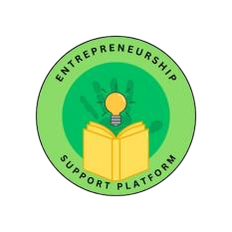

:

Adjournment

The meeting was closed at exactly 11:00.

Approval

**Minutes approved by:**

Sibusisiwe Kunene

06 September 2024 2024